**Advanced level**

**1. The theorem about the connection between the differentiability and the continuity**

**Answer:** Analysis_2_Csorgo.pdf 3.4 theorem, page 17

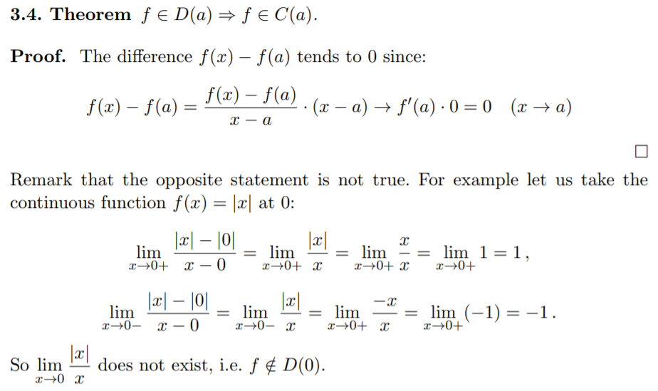

==================================================================================

**2. The derivatives of the following functions: c, ax + b, x^n , e^x , sin x**

**Answer:** Analysis_2_Csorgo.pdf 3.2 paragraph, page 17-18

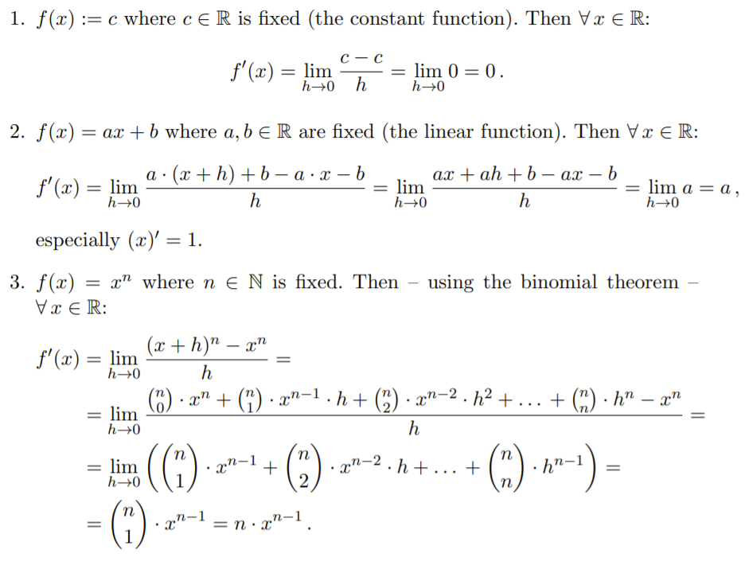

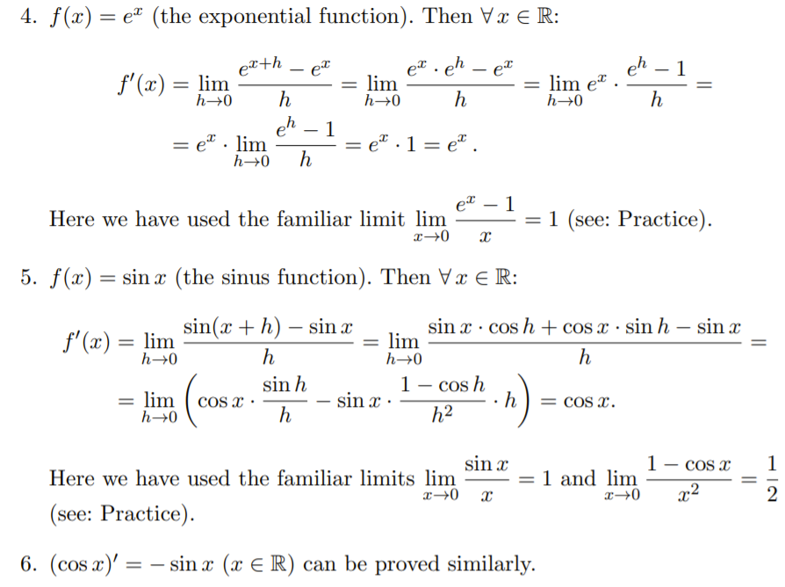

==================================================================================

**3. The derivative of the sum**

**Answer:** Analysis_2_Csorgo.pdf 3.5 theorem, page 18

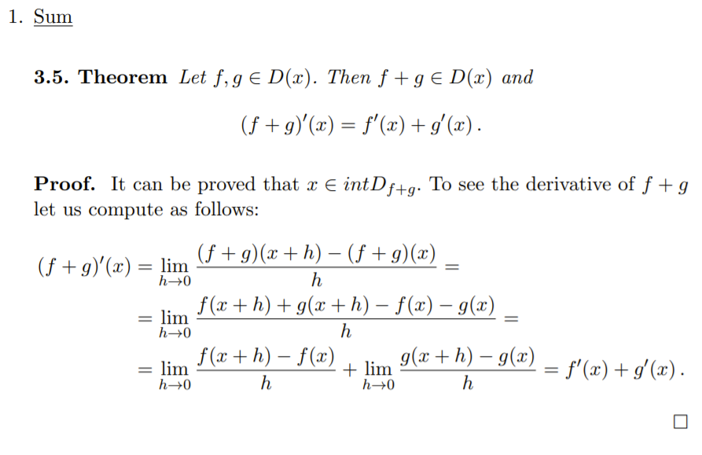

==================================================================================

**4. The derivative of the product**

**Answer:** Analysis_2_Csorgo.pdf 3.6 theorem, page 19

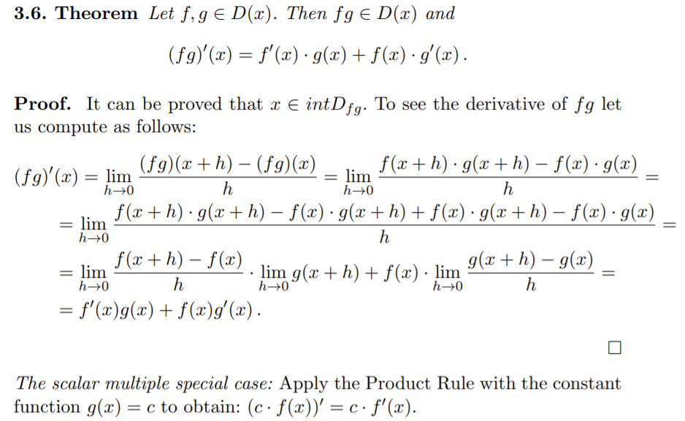

==================================================================================

**5. The derivatives of tan x, ln x, a^x**

**Answer:** Analysis_2_Csorgo.pdf 3.4 pararaph, page 20

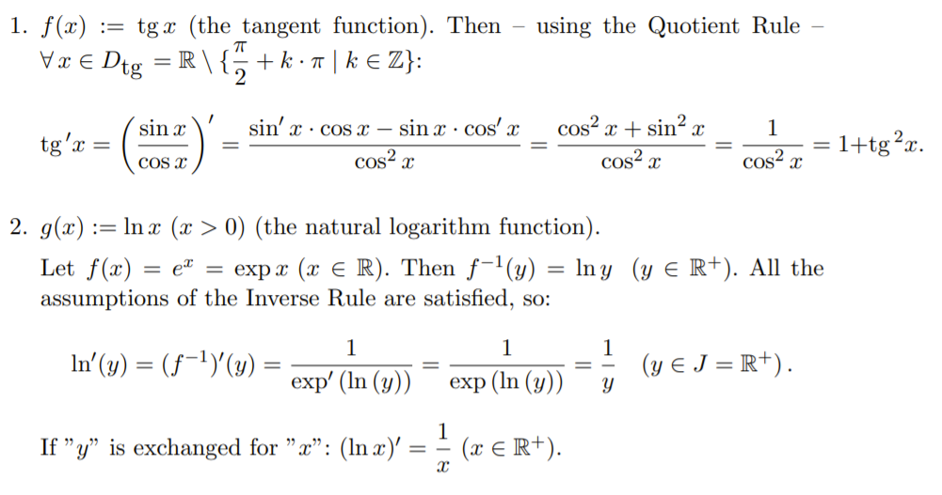

==================================================================================

**6. The derivative of arcsin and of arctan**

**Answer:** Analysis_2_Csorgo.pdf 4.11 definition, page 26

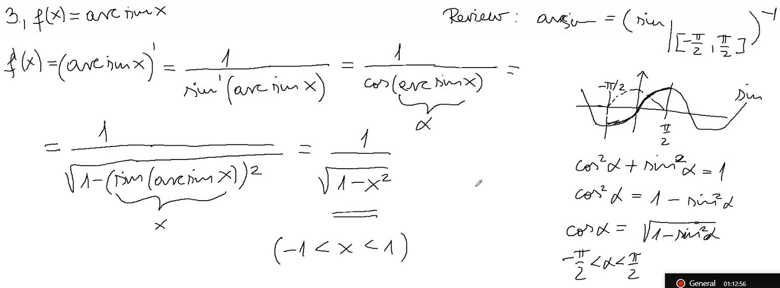

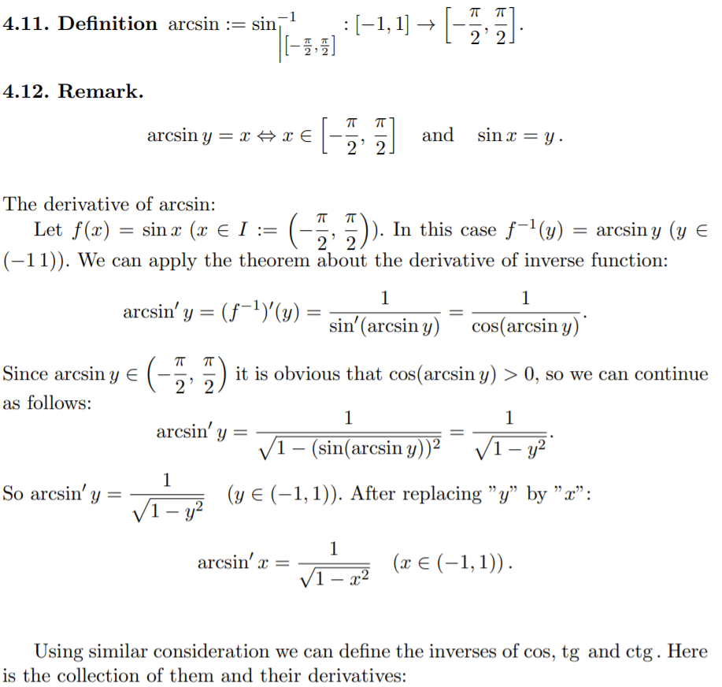

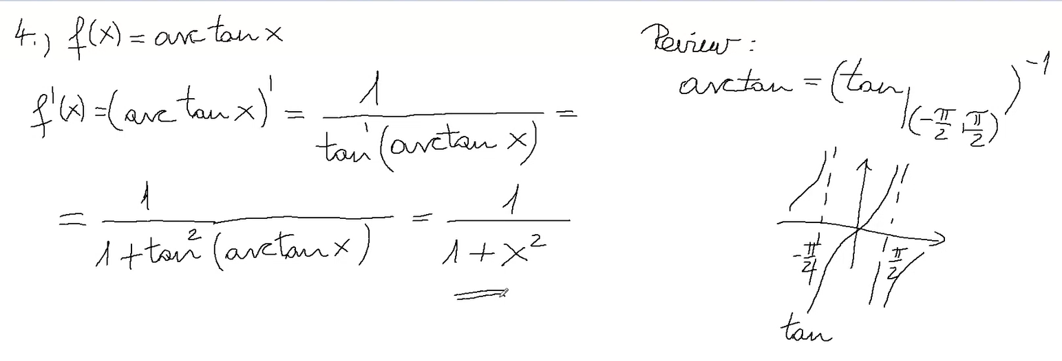

==================================================================================

**7. The First Derivative Test (First Order Necessary Condition) for local extremum**

**Answer:** Analysis_2_Csorgo.pdf 4.2 theorem, page 22

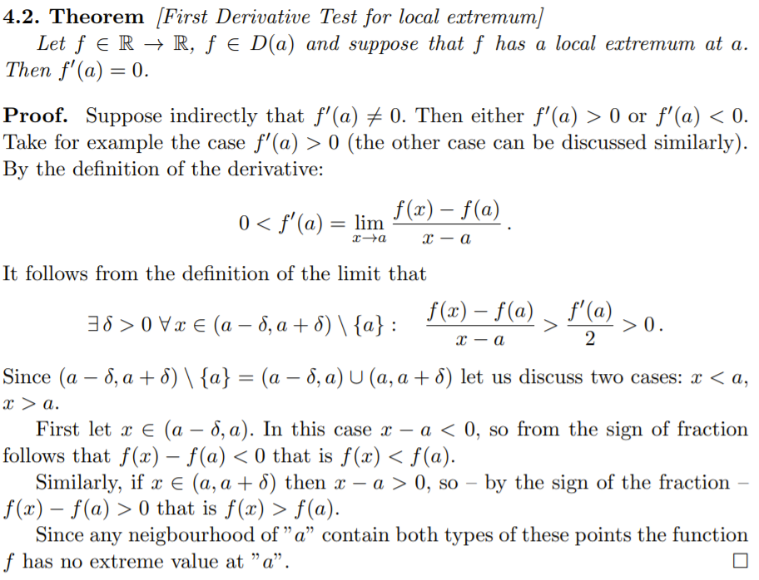

==================================================================================

**8. Rolle’s Mean Value Theorem**

**Answer:** Analysis_2_Csorgo.pdf 4.4 theorem, page 23

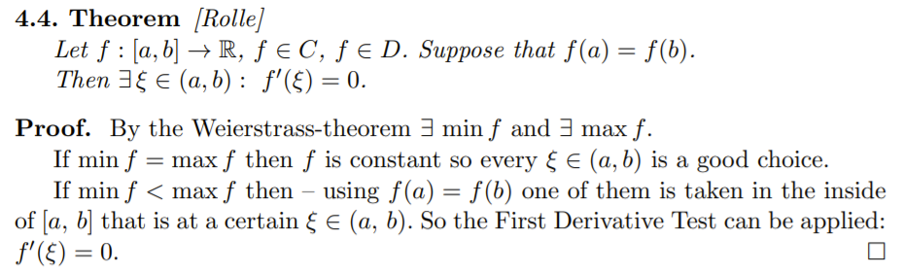

==================================================================================

**9. Cauchy’s Mean Value Theorem**

**Answer:** Analysis_2_Csorgo.pdf 4.5 theorem, page 23

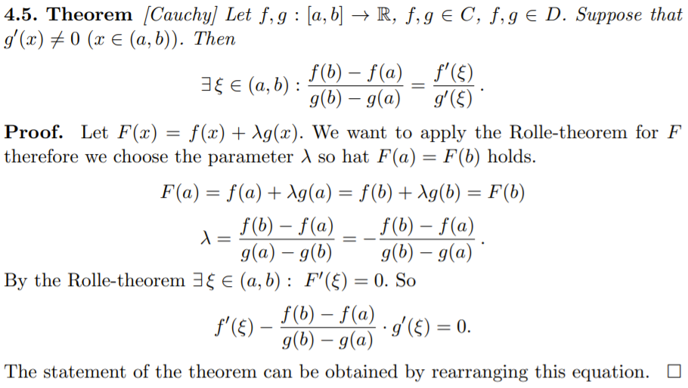

==================================================================================

**10. Lagrange’s Mean Value Theorem**

**Answer:** Analysis_2_Csorgo.pdf 4.6 theorem, page 23

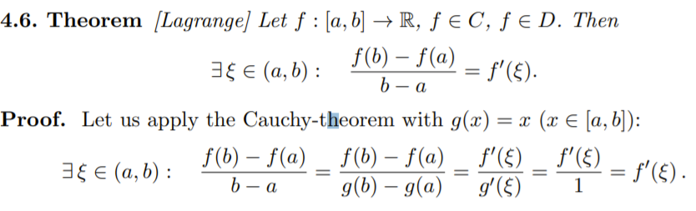

==================================================================================

**11. The First Derivative Test for monotonicity**

**Answer:** Analysis_2_Csorgo.pdf 4.7 theorem, page 24

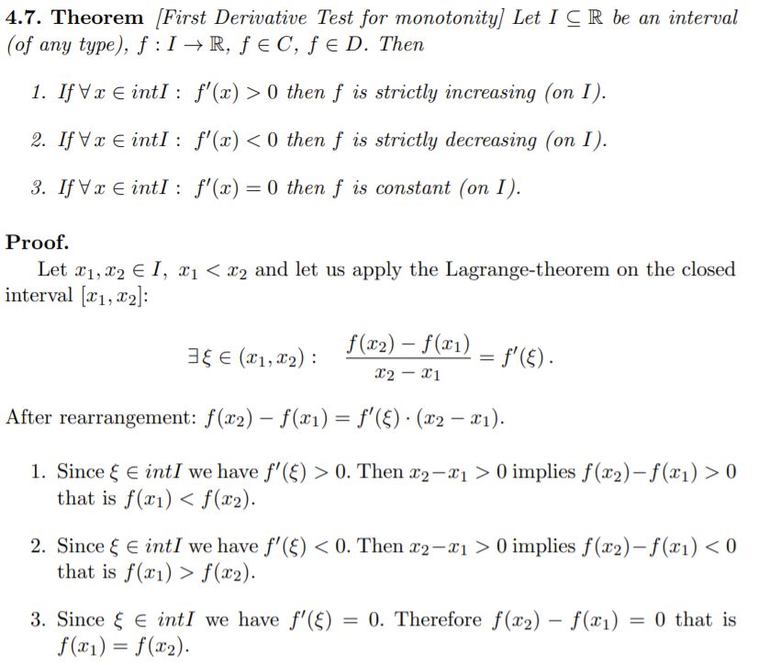

==================================================================================

**12. L’Hospital’s Rule (the case that was proved on the lecture)**

**Answer:** Analysis_2_Csorgo.pdf 5.1 theorem, page 28

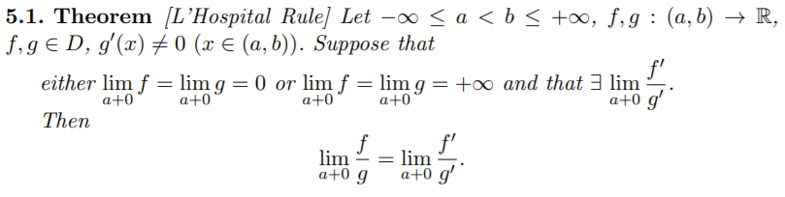



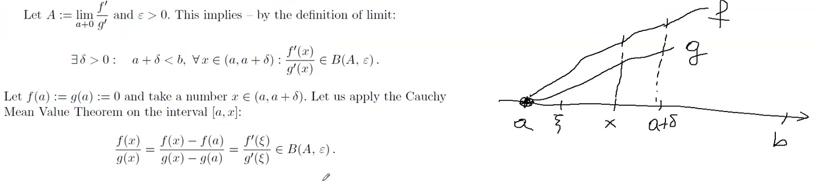

==================================================================================

**13. The connection between the derivatives of a function and of its Taylor-polynomials. Prove it for the 0-th and for the 1-st derivatives.**

**Answer:** Analysis_2_Csorgo.pdf 3.4 theorem, page 17

==================================================================================

**14. The theorem about the Taylor-formula**

**Answer:** Analysis_2_Csorgo.pdf 5.6 theorem, page 30

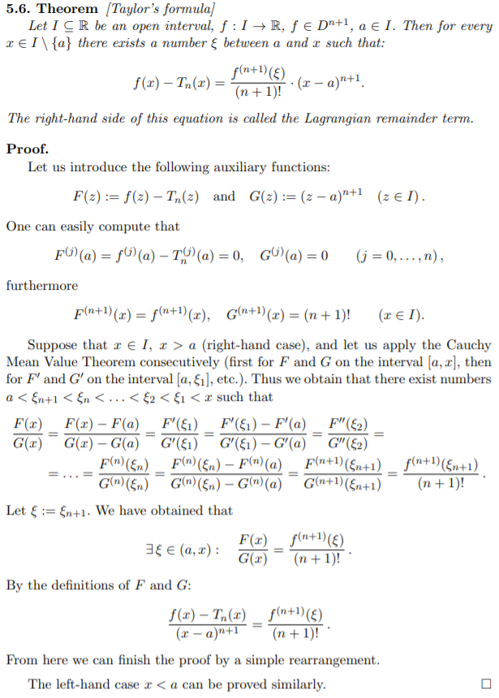

==================================================================================

**15. The theorem about the set of all antiderivatives of a function**

**Answer:** Analysis_2_Csorgo.pdf 6.2 theorem, page 33

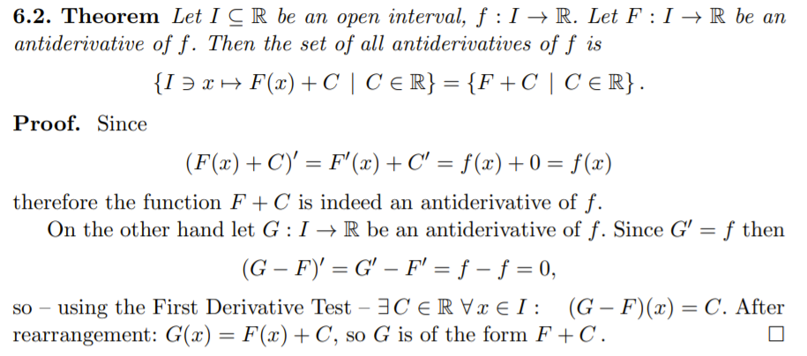

==================================================================================

**16. The 5 simple integration rules**

**Answer:** Analysis_2_Csorgo.pdf 6.5-6.8 theorem, page 34-35

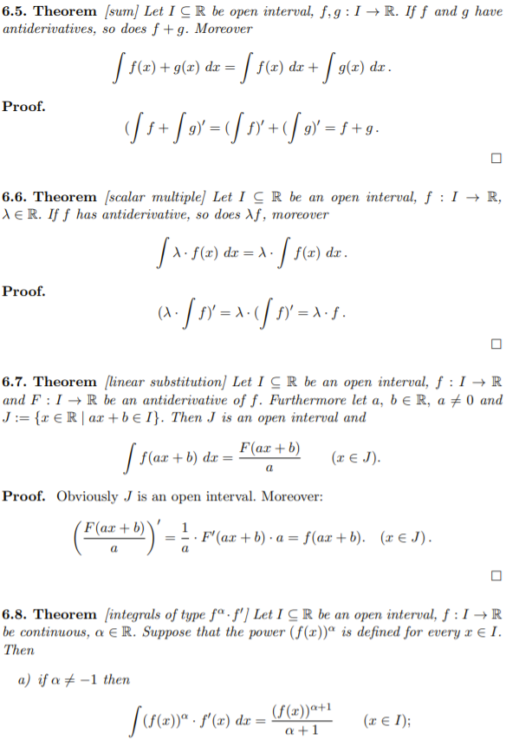

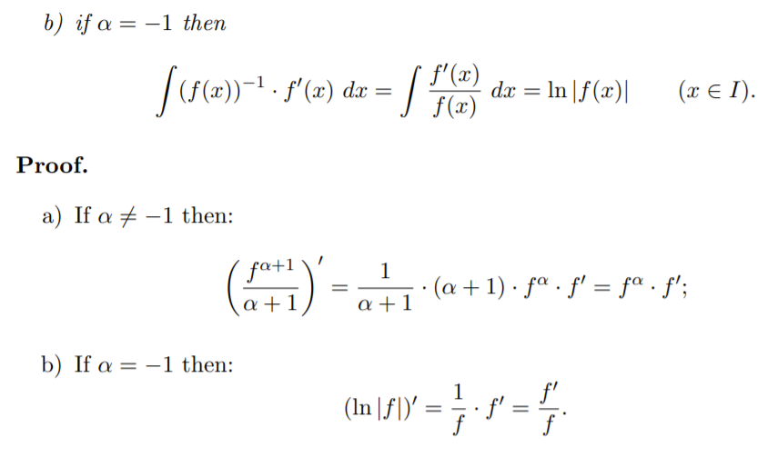

==================================================================================

**17. The rule of Integration by Parts for antiderivatives**

**Answer:** Analysis_2_Csorgo.pdf 7.1 theorem, page 38

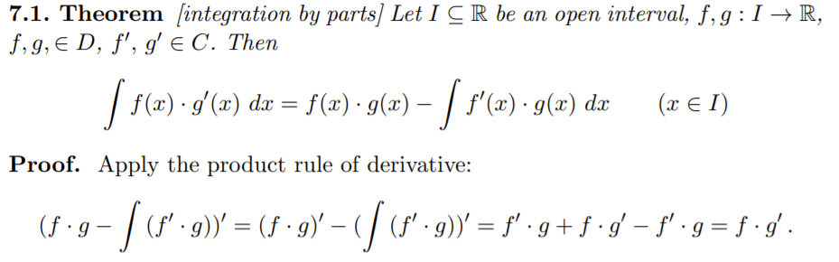

==================================================================================

**18. The rule of Substitution Form I. for antiderivatives**

**Answer:** Analysis_2_Csorgo.pdf 7.2 theorem, page 38

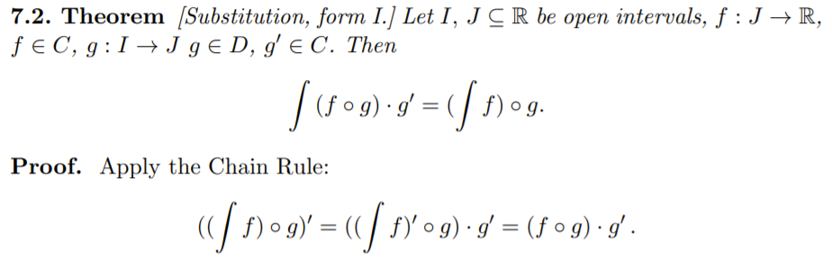

==================================================================================

**19. The theorem about the continuity of the Integral Function**

**Answer:** Analysis_2_Csorgo.pdf 9.5 theorem, page 49

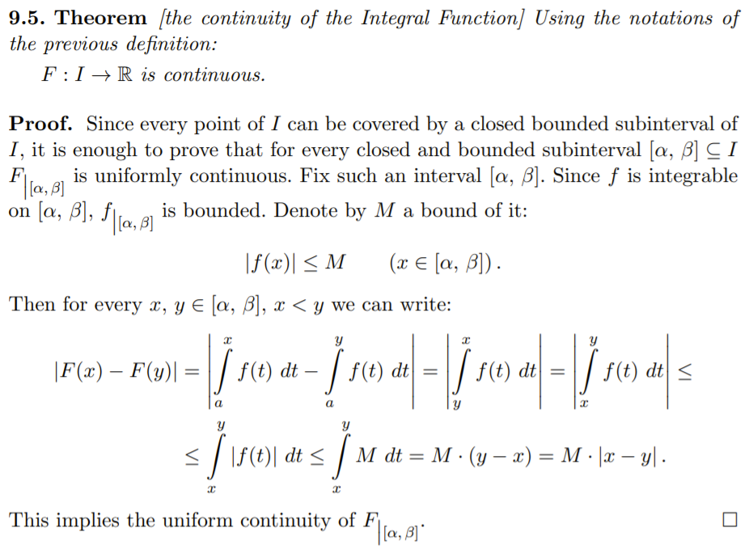

==================================================================================

**20. The Fundamental Theorem of Calculus (the Newton-Leibniz Formula)**

**Answer:** Analysis_2_Csorgo.pdf 10.1 theorem, page 51-52

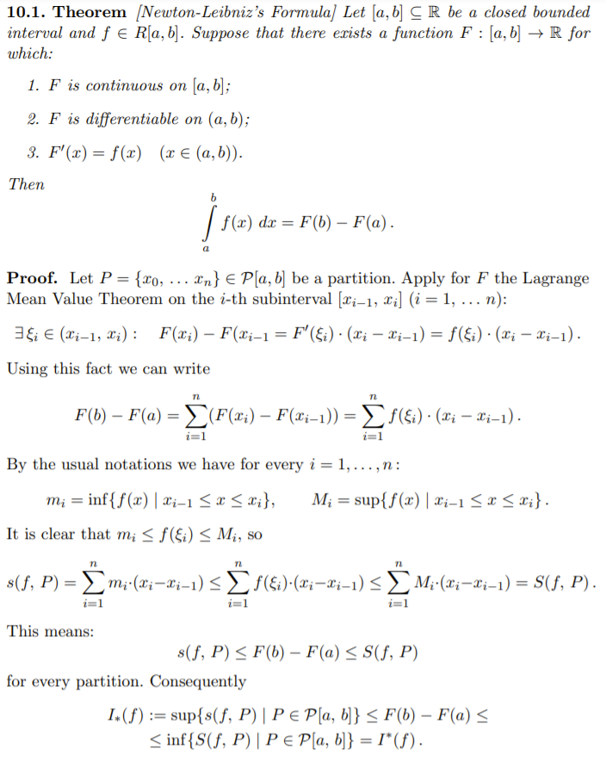

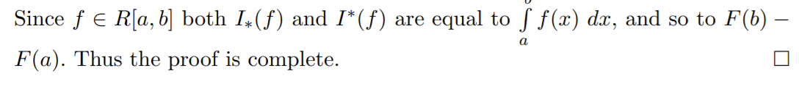

==================================================================================

**21. The rule of Integration by Parts for definite integrals**

**Answer:** Analysis_2_Csorgo.pdf 10.3 theorem, page 52

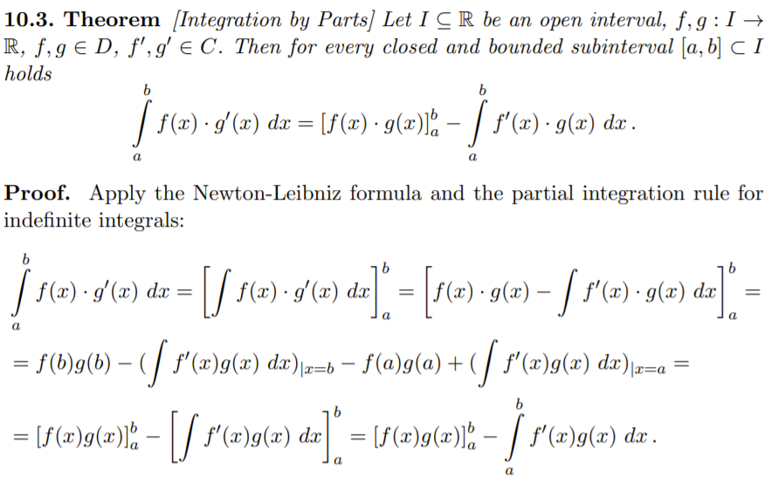

==================================================================================

**22. The First Derivative Test (First Order Necessary Condition) of local extremum for functions of type R^n → R**

**Answer:** Analysis_3_Csorgo.pdf 8.2 theorem, page 41

